Exp1:-
Title of the program:-
Write a program to find out Armstrong numbers between 1 to 1000.
Program instruction:-
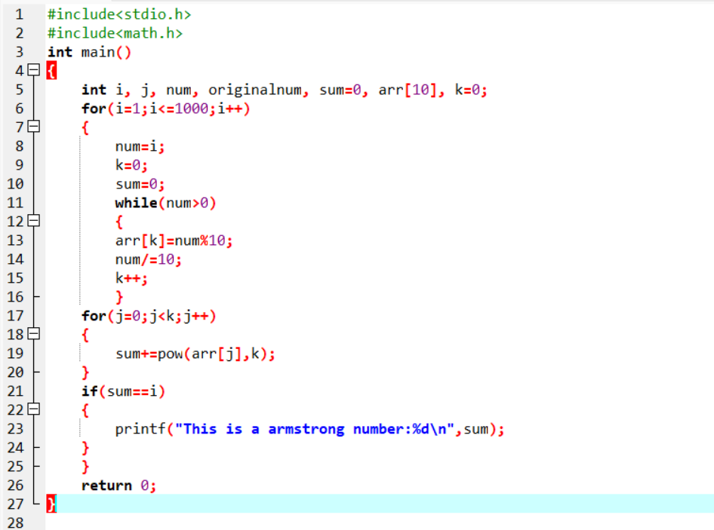
Output:-

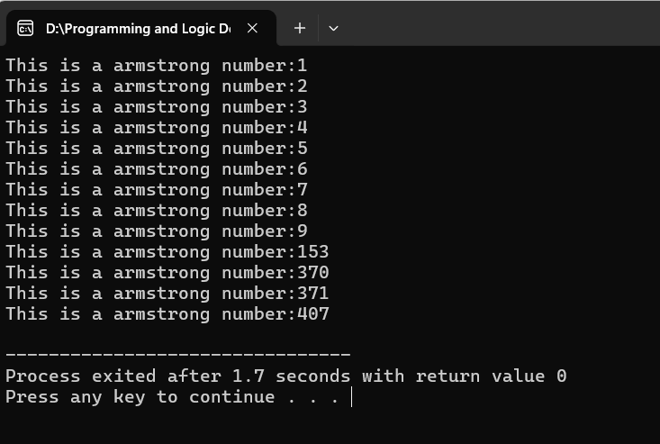
Exp2:-
Title of the program:-
Write a program to take book details(title,author,edition & acc.no) of 10 books & display the result. If search a book by its acc.no then the other details will be printed.
Program instruction:-
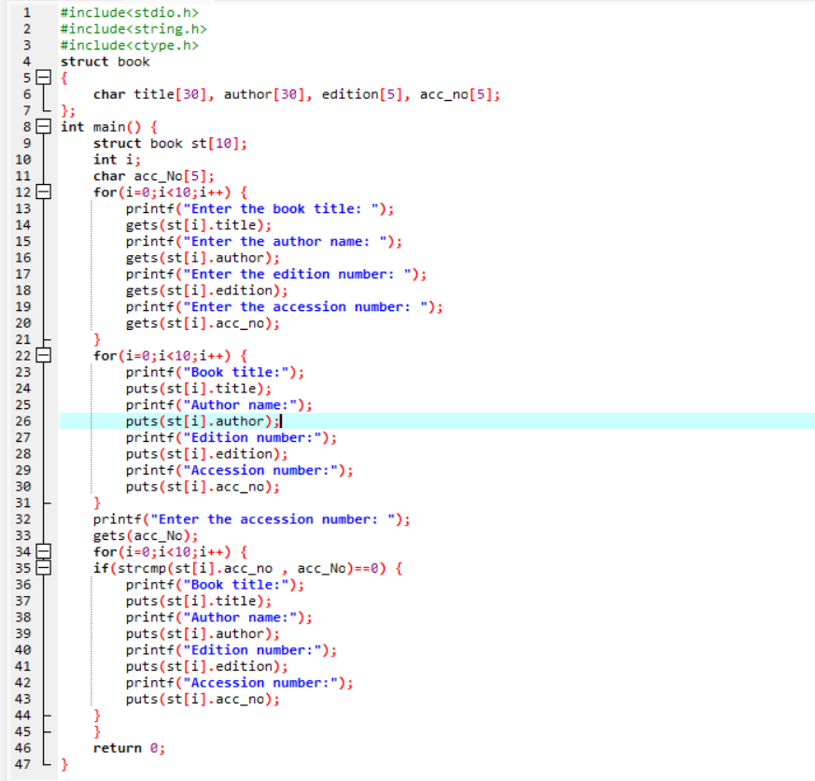

Output:-

